**E-Fixed Deposit for ABC Bank**



**Submitted by:**

Mohit Pal

Table of Contents

1- Introduction 3

2- Identify stakeholders 4

3- The proposed system workflow 4

As-Is Process map: 4

Future Process map: 5

4- Finding the Scope of E-Fixed Deposit (Context Diagram) 5

Main features of E-FIXED DEPOSIT 6

5- The In-scope and Out of Scope Items for E-FIXED DEPOSIT 7

9- Key functional and Non-functional requirements 7

6- Wireframe for Update menu page and table booking 8

FD Calculator Page 8

FAQ Page 8

7-User stories and Acceptance criteria 9

8-Sales Analysis by Region on Tableau 9

9- Excel Work 10

9.1- FD sales for different periods of investment 10

9.1.2.1-Ascending order of Total amount 11

9.1.2.2-Decending order by Total amount 11

9.2-Find Sales 12

9.2.1- Find the rate for senior citizens for amounts less than 2 crore for Product HDH 12

9.2.2- Find the rate for senior citizens for amounts less than 2 crore for Product YFF 12

# 1- Introduction

One of the leading banks across the globe, is ABC Bank. It has a presence in 56 countries in the world.

ABC Bank currently has a manual option to create fixed deposits. The bank users go to the nearest ABC Bank branch and create a fixed deposit. ABC Bank has a future vision of being a 100% online bank and wants to do away with all its manual banking processes. They have identified the need to create e-fixed deposits.

ABC Bank currently wants to introduce this to their existing bank users with a future plan of introducing this feature to non-ABC Bank users.

Advantages of opening an FD online

* **Easy and less time-consuming**: An online FD can eliminate the process of visiting the bank physically and makes the process of creating an FD an extremely easy and hassle-free process.
* **Easy payment:**Paying for the FD is extremely easy and can be done directly through net banking that makes the process of payment very convenient. All that is required is to transfer the money from the savings account to the respective FD account.
* **Easy renewal and closure:** Once an FD account is opened online, it is possible to renew and close the deposit online instantly. Therefore, it eliminates the need of going to the bank for any of these purposes.

# 2- Identify stakeholders

RACI matrix is used here for identifying the responsibility of each stakeholder involved in the process:

Responsible (R): The individuals who will be performing the work on the task.

Accountable (A): The individual who is ultimately answerable for the completion of the task and is the decision maker.

Consulted (C): The stakeholder (group) who will be asked to provide opinion or information about the task.

Informed (I): The stakeholder (group) that is kept up to date on the task and its outcome.

|  |  |  |  |  |
| --- | --- | --- | --- | --- |
| **Stakeholders** | **Responsible** | **Accountable** | **Consulted** | **Informed** |
| Project Manager |  | A |  |  |
| Implementation SME | R |  |  |  |
| Tester | R |  |  |  |
| Domain SME |  |  | C |  |
| Operational Support |  |  | C |  |
| Supplier |  |  |  | I |
| Business Analyst | R | A |  |  |
| Sponsor |  |  | C | I |
| End User |  |  |  | I |
| Customer |  |  |  | I |
| Regulators |  |  | C |  |

# 3- The proposed system workflow

## As-Is Process map:

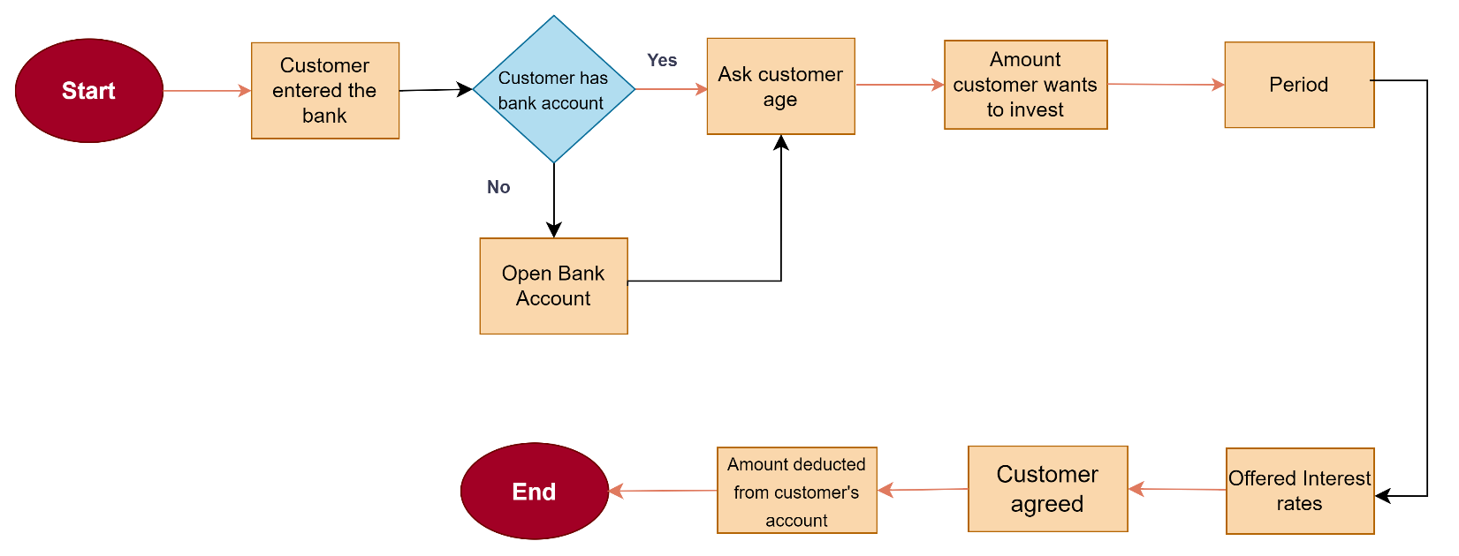

## Future Process map:

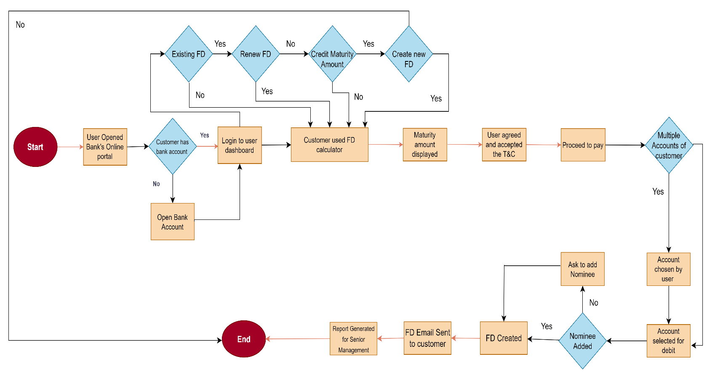

# 4- Finding the Scope of E-Fixed Deposit (Context Diagram)

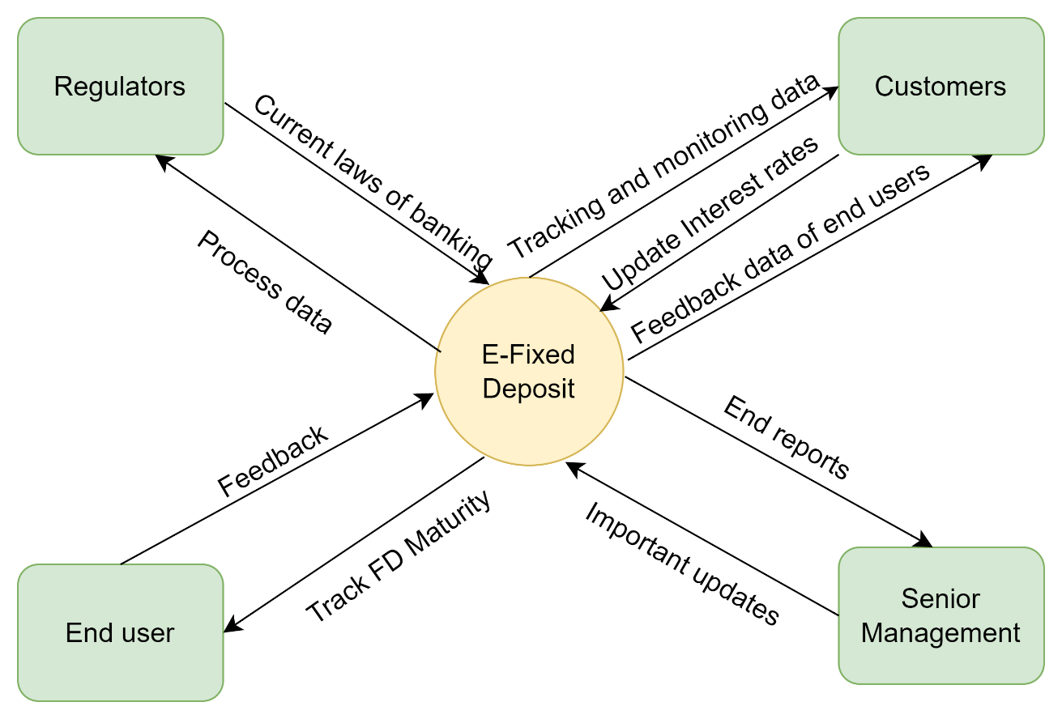

## Main features of E-FIXED DEPOSIT

1. Web-based Management System

* Must have MYSQL database and operate with Windows 2016
* Must have 2 login portals
* Must respond within 1 second
* Must be interactive and user-friendly
* Must be working all the times

1. User and Senior Management Registration and Login
2. A fixed deposit calculator
3. Select which account to debit for the FD
4. Nominee Option
5. Renew FD for same tenor
6. Credit Maturity amount to customer’s account
7. Joint FD option
8. Email PDF copy of FD
9. Reports for Senior Management

* Total value of FDs for users with tenor of less than 6 months.
* Total value of FDs for senior citizens with tenor of less than 6 months.
* Total value of FDs for users with tenor of between 6 months 1 day and 1 year.
* Total value of FDs for senior citizens with tenor of between 6 months 1 day and 1 year.
* Number of FDs that are more than 1.5 Million USD for normal users.
* Number of FDs that are more than 1.5 Million USD for senior citizen users.

# 5- The In-scope and Out of Scope Items for E-FIXED DEPOSIT

|  |  |
| --- | --- |
| **In-Scope Requirements** | **Out-of-Scope Requirements** |
| Login customer portal | Only customers of ABC bank |
| Opening Bank FD | Only customers who have bank accounts in ABC Bank |
| Senior Management dashbaord | Only SM can login |
| Interest rates | Must be based on Age, Tenure and Amount. |
| Fixed deposit calculator | Must ask for Age, Tenure and Amount. |
| Debit for FD | Only if customer has multiple account |
| Renew FD Option | Only if customer already has an existing FD |
| Joint FD Option | Only if the customer wants |
| Reports generation | Reports must be generated at the end |

# 9- Key functional and Non-functional requirements

1. **Functional Requirements:**

* Customer account opening page
* Log- in screen for Customer and Senior management
* FD Calculator
* Renew FD page
* Credit maturity page
* Joint FD Page
* Nominee page
* Email PDF copy of FD button
* FD PDF display page
* Reports for senior management
* Procced to pay page

1. **Non-functional Requirements:**

* MySQL Databaseto be used since it is open source and free.
* Creating and maintaining the program in Java
* The operating systemshall be Windows 2016
* The system shall be a web-based application.
* The system shall respond within 1 second
* The system shall keep logs of all the errors
* The system shall be available all the time
* The system should be self-explanatory and very user-friendly.

# 6- Wireframe for Update menu page and table booking

## FD Calculator Page

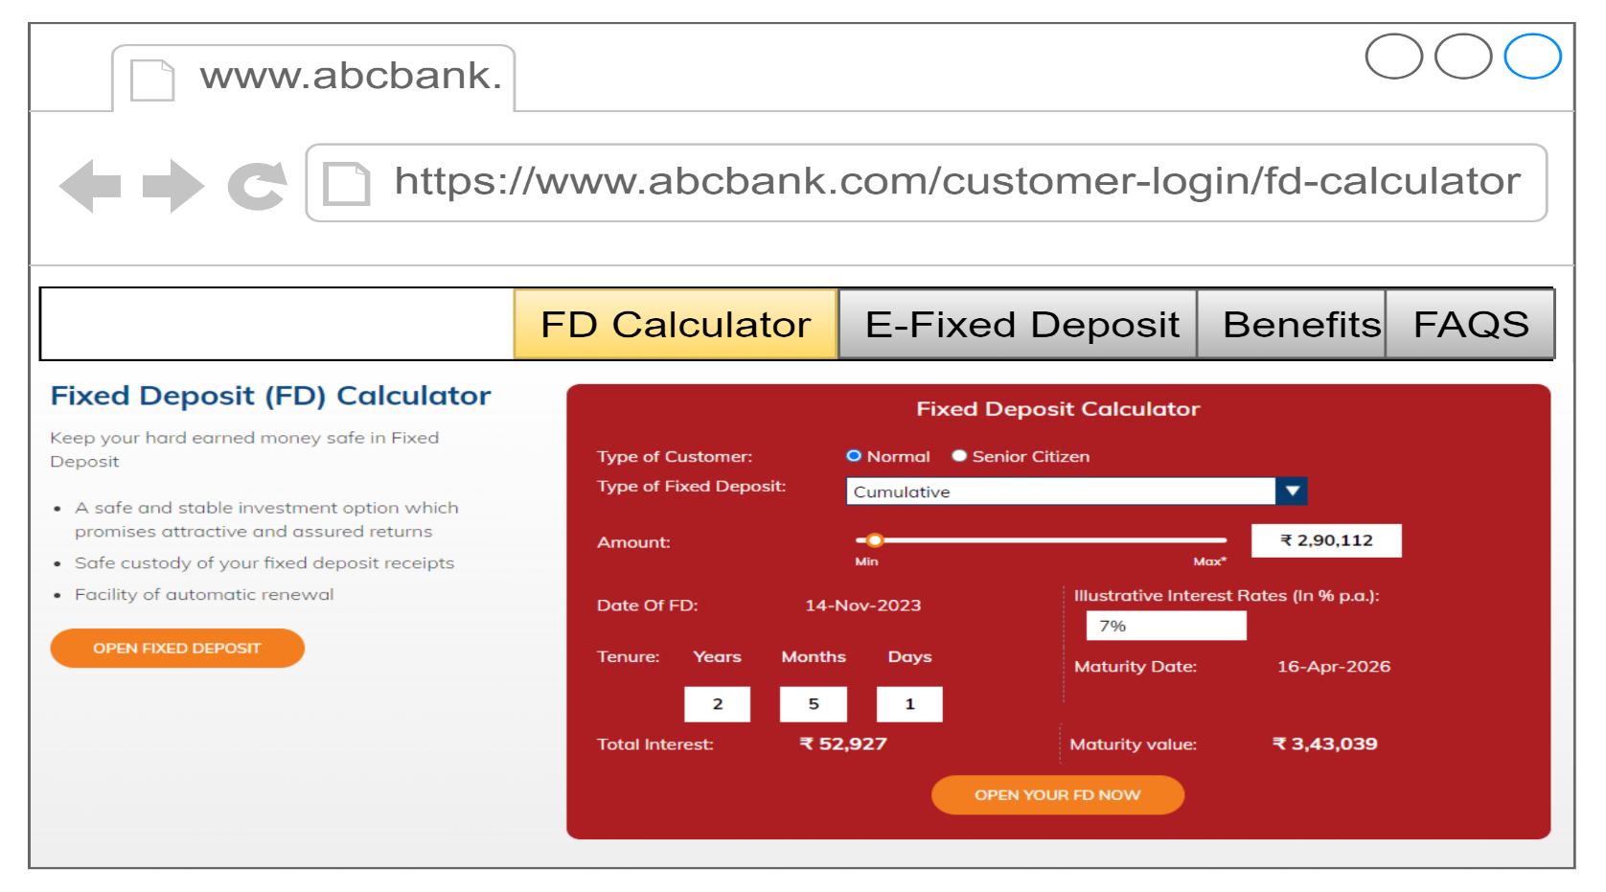

## FAQ Page

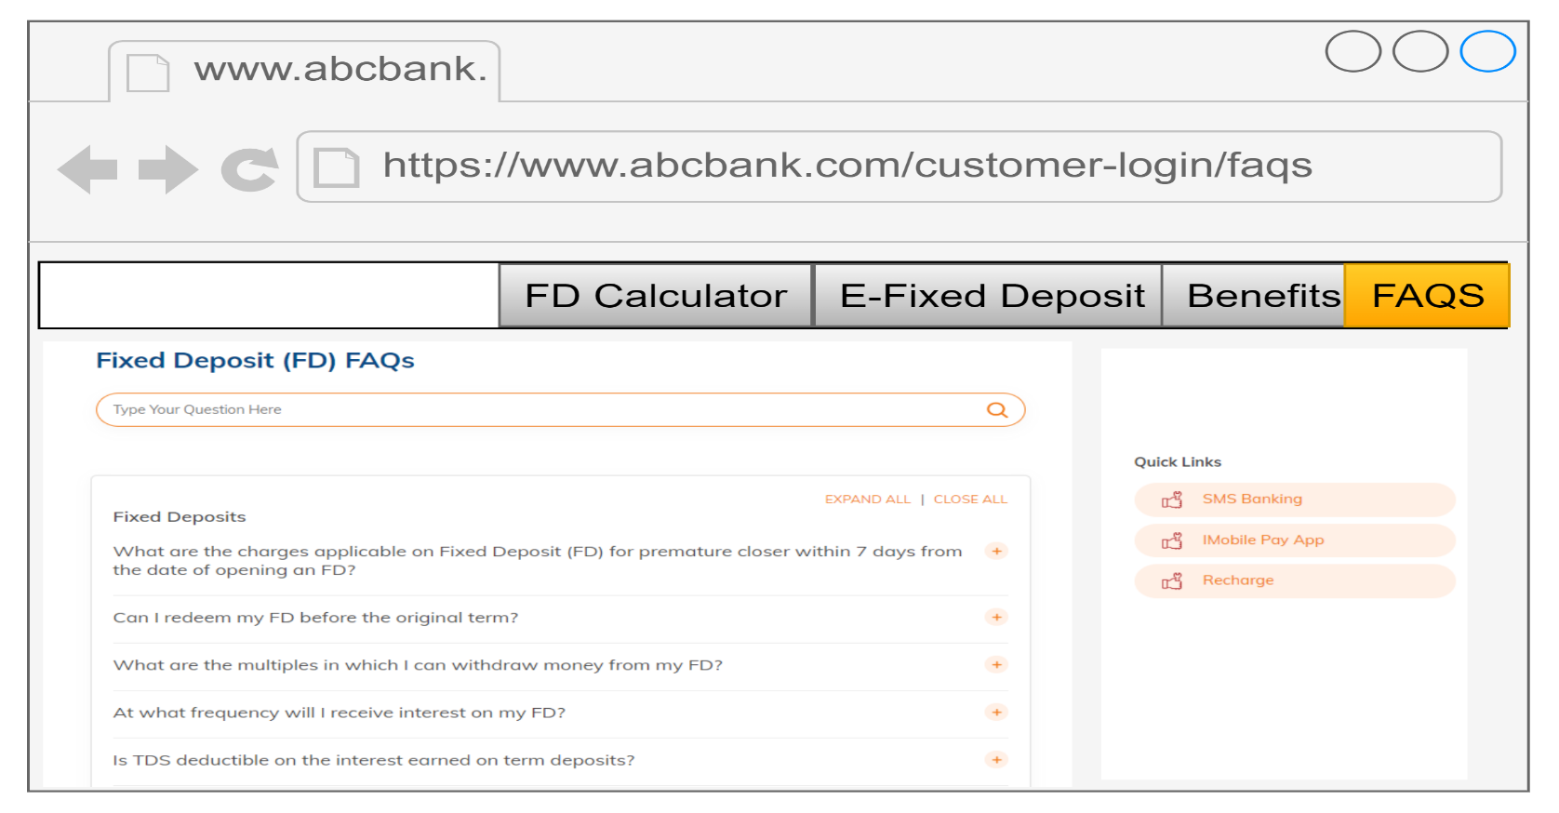

# 7-User stories and Acceptance criteria

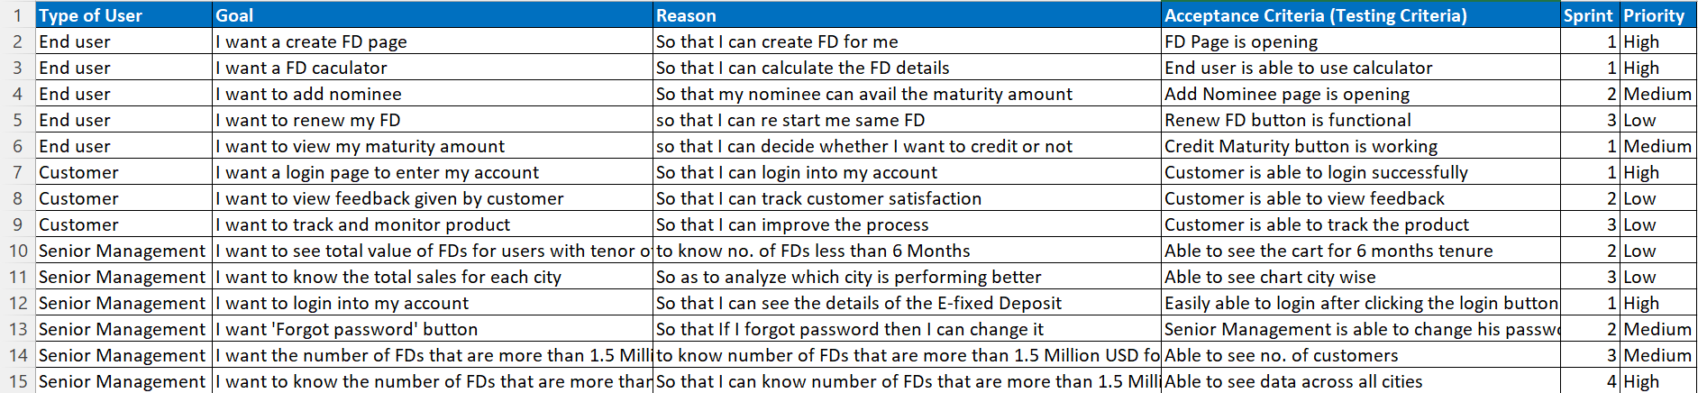

# 8-Sales Analysis by Region on Tableau

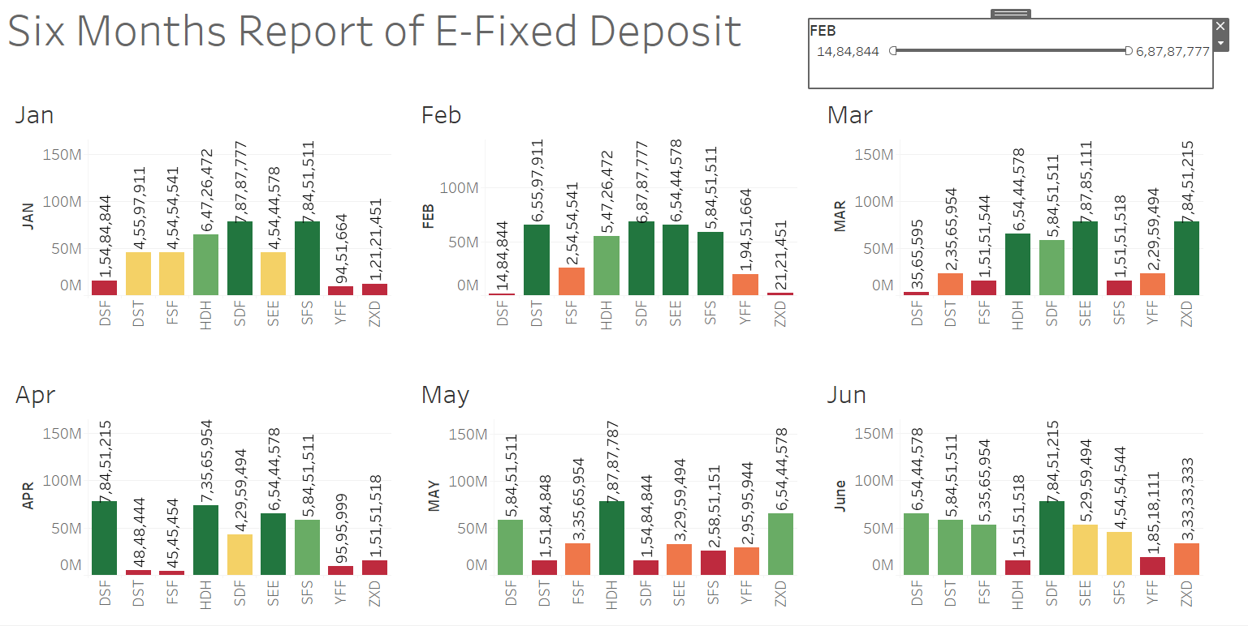

# 9- Excel Work

## 9.1- FD sales for different periods of investment

## 9.1.2.1-Ascending order of Total amount

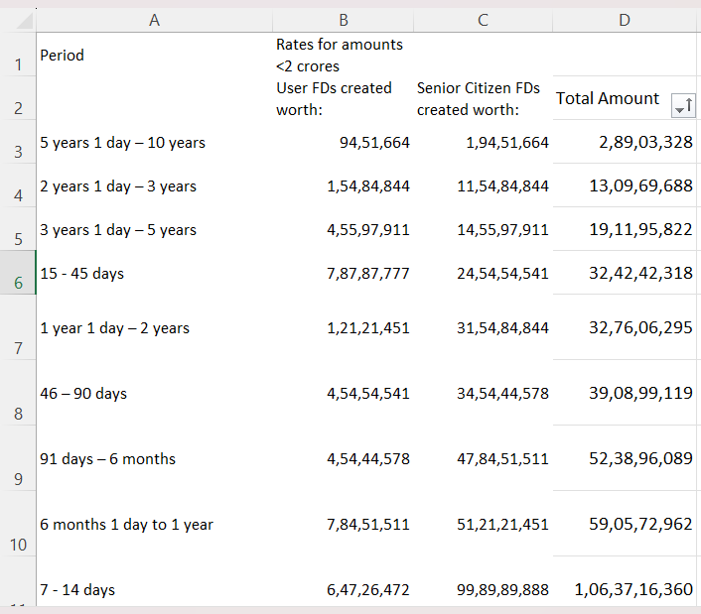

## 9.1.2.2-Decending order by Total amount

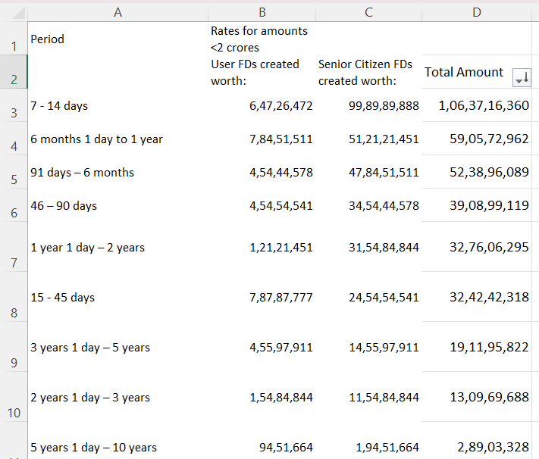

## 9.2-Find Sales

## 9.2.1- Find the rate for senior citizens for amounts less than 2 crore for Product HDH

Answer- 3.00% V Look UP Formulae: =VLOOKUP(B4, A1:F12, 3, FALSE)

## 9.2.2- Find the rate for senior citizens for amounts less than 2 crore for Product YFF

Answer- 5.75% V Look UP Formulae: =VLOOKUP(B12, A1:F12, 3, FALSE)